

**Performance Management System**

Ver 1.0.2

Date: 03/05/2018

Author: IIS & HR



Contents

1 EMPLOYEE SECTION 3

2 MANAGER’S SECTION 15

3 SELF HELP GUIDE 23

# EMPLOYEE SECTION

|  |
| --- |
| 1. Check the browser compatibility configuration for PMS application. Path: IE > Tools > Compatibility View Setting   cid:image001.png@01D20FFC.C988B2C0 |
| 1. Log-on to [https://www.majesconet.com](https://www.majesconet.com/) |
| 1. Quick Links 🡪 Performance Management 🡪 Application 🡪 PMS   Application |
| 1. Click on *KRA Setting /Performance Assessment* link to Open KRA setting   page |
| 1. You should be on KRA settings page now as shown below   To add new KRAs, Click here. Then click on ‘Add New KRA’ Button to view KRA entry form. |
| 1. Add KRA form like shown below should appear. |
| 1. Understanding how KRA Settings work    * + - 1. Key Points:  * Minimum 5 KRAs * KRA category can be any of the provided options * Sum of % weightage of individual KRA must be equal to 100 %. * Performance measures FE, EE and ME mandatory for each Activity      * + - * 1. Components: * KRA Category – Delivery   Customer  Financials  People  Organization   * KRA Description and KRA Weightage * Activity and Performance Measures * Self Rating and Manager Rating Disabled during KRA settings * Control Buttons – Save & Add, Save & Close, Reset and Cancel.   + - * 1. Send for Sign-Off: * Learning Plan * Additional Development Plan * (At least one of the above) |
| 1. To Edit/Delete existing KRAs, Click on hyperlink of the desired KRA and make modifications or delete KRA from the bottom panel of KRA setting window. (See illustration)     Hyperlinked KRA (to be modified/Deleted)  Edit and Save KRA  Delete KRA |
| 1. Ensure validations criterions in step 7 are met. |
| 1. After setting the KRAs, Learning Plan and/or Additional Development Input should be set.   Click to Expand and further click on ‘Add New’ |
| 1. Feed new Learning Plan and/or Additional Development Input |
| 1. On successfully completing above steps, The KRAs are ready to be sent for Sign-Off. Clicking ‘Send for Sign-off’ button on bottom right of the screen sends it for approval of Current Manager of the employee. 2. Employee’s ‘My PMS records’ and ‘KRA Setting’ should look like below screen after sending for sign-off. |

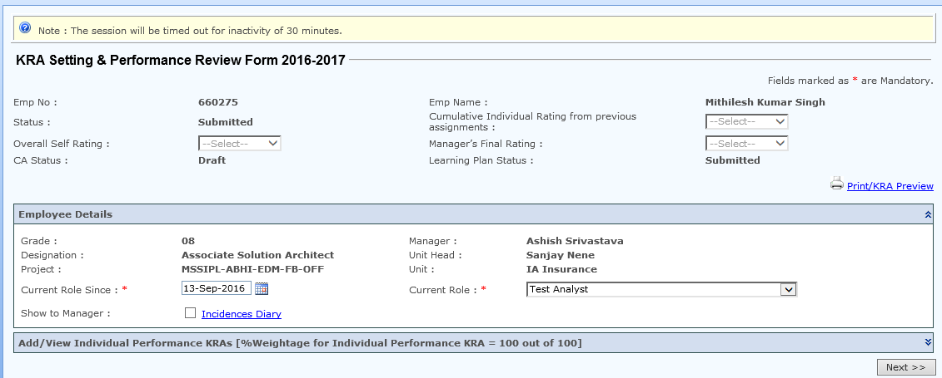

14. Employee has to select Overall Self Rating for the assessment year

Individual’s Performance Assessment details would be displayed on

click of icon highlighted.

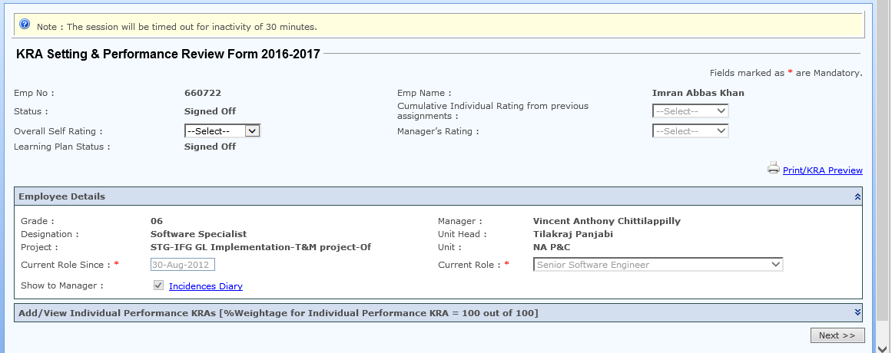

|  |
| --- |
| 1. Employee has to enter “Details of Achievement on KRA” and “Over all   Self rating” for each KRA item. Click on Key Result Areas |

1. Enter Details of Achievement on KRA & Key Result Areas for the selected KRA

* Select Over All Self Rating from dropdown for the KRA
* Click on ‘Save & Close’ button to save Details of Achievement on KRA against selected Category.

Similarly enter Details of Achievements rest of categories & Key Result Areas

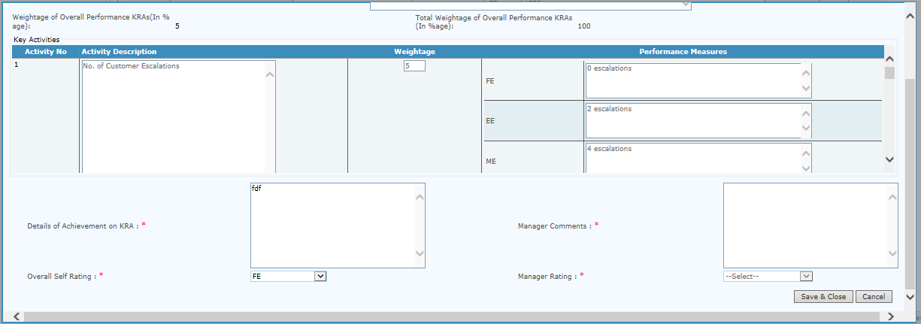

1. Update Training status, review date and Save

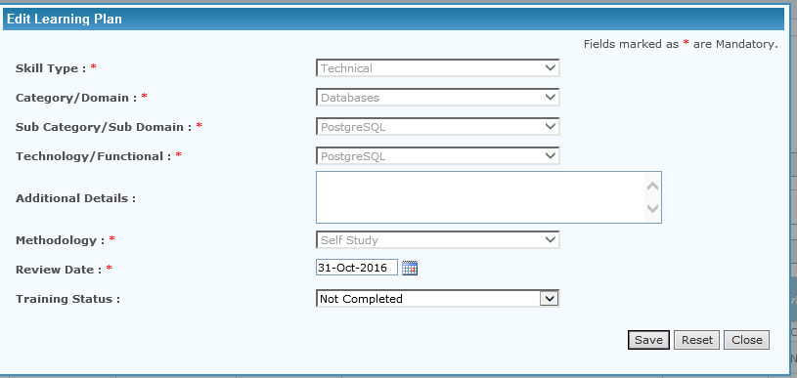

1. Click On Next button after updating all the KRA item

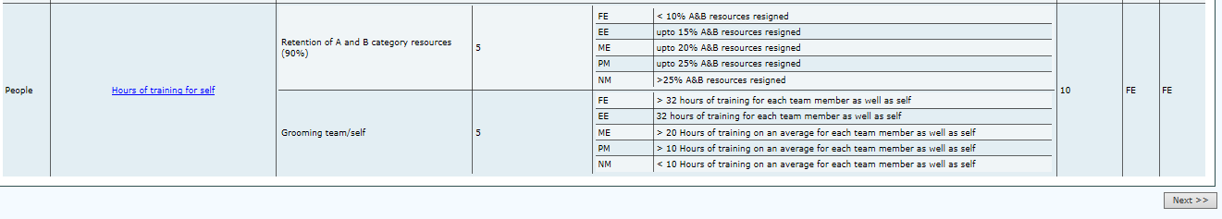

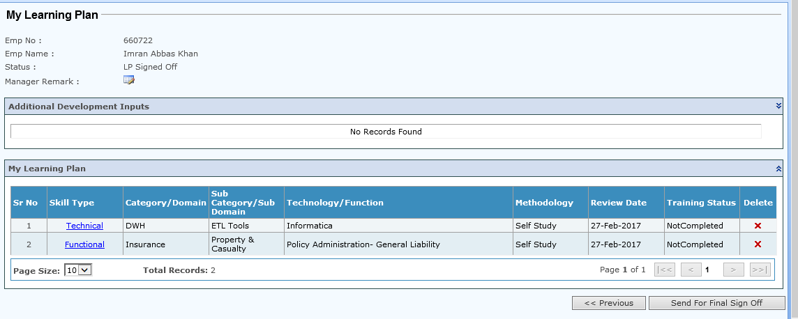

1. Click on ‘Send For Final Sign Off’ after updating learning plan/Additional Development input

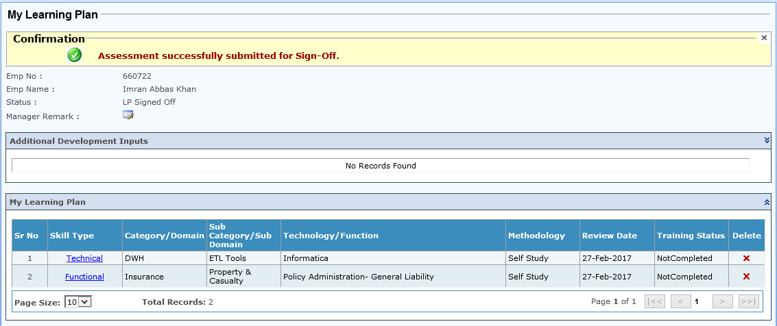

1. An Alert as well Email will be triggered to supervisor for Assessment Sign Off.

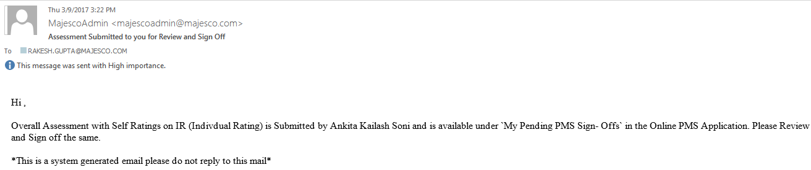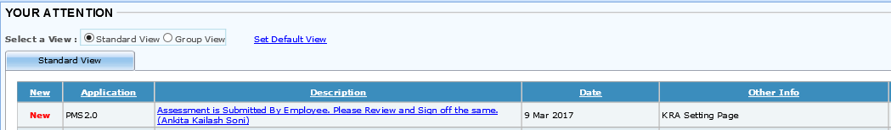



1. New KRA for current Project

* Click on KRA Setting/Performance Assessment link.
* Rollout / open the next dropdown highlighted ‘Add / View individual Performance KRAs’
* Copy previous KRAs: This will copy Previous KRA Category, Key Result Areas, Key Activities, Sub Weightage & overall weightage.

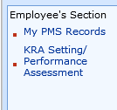

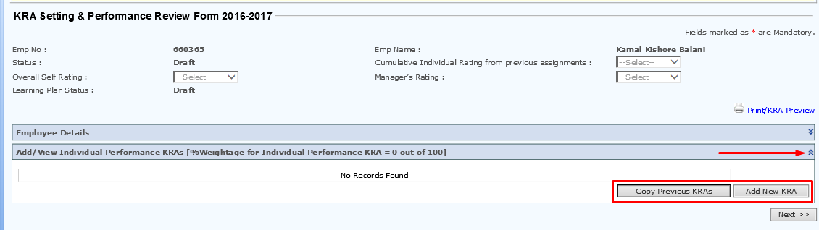

My PMS Records

* In Employee’s section Employee can see Performance Records through ‘My PMS Records’ link.

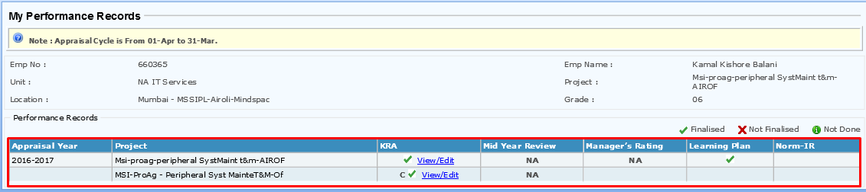

# MANAGER’S SECTION

|  |
| --- |
| 1. Manager receives an Alert as well as a mail when any employee mapped to them submits/edits/deletes their KRA/Learning Plan/Additional Development Input. |
| 1. To make the sign-off or request changes from the employee, manager have to go to their PMS portal and select ‘My Pending PMS SignOffs’        * Clicking on the hyperlinked name opens the KRAs set by the employee. * Manager can view the KRAs * Manager can view development and/or learning plan * Manager can Reject the KRAs with Remarks * Manager can Accept /Sign-off the KRAs |
| 1. KRAs can be viewed by expanding the bellows on employee’s PMS window and ‘Next’ button thereafter navigates to the Learning Plan/Development Plan. Manager can Reject or SignOff the same from here.   View Learning Plan  Reject with Remarks  Accept and SignOff |
| 1. Using Majesco’s PMS Application, A Manager also can submit KRA on behalf of those who report to him/her.   Go to : PMS Application > Set KRA on Behalf >  Select Employee > Show |

|  |
| --- |
| 1. Status Reports can be generated and Exported in .xls format from the ‘Status Report’ link in Manager’s section of PMS Application.  * Select group, scope, grade, location, unit, account and project. * Click on show to view complete KRA status report of corresponding Employees and Export the same. |

|  |
| --- |
| 1. ‘ My Team PMS Record’ is the section which gives a consolidated view of the KRA and assessments of entire team under a particular Manager.  * Manager can refine the desired records as per the requirements.      * Manager can also view detailed KRAs from here by clicking on the Ok/Check icon corresponding to the particular person. |
| 1. Team Learning Plan link can be seen below the Team PMS Record link.      * There is a separate button for Exporting the record to .xls ( Excel) format.  1. Supervisor’s Section: My Pending PMS Assessment Signoff  * Click on ‘My pending PMS Signoffs’ for Final Assessment submitted by employees for approval * Manager can view, enter comments and give individual KRA ratings        1. Supervisor has to Select Manager’s Rating for the assessment year   cid:image001.png@01D3B47C.3A314C10   1. Supervisor has to Select Manager Rating and Manager comments for each KRA item   cid:image002.png@01D3B47C.3A314C10   1. Click on Next button to review learning plan and final Sign Off.   cid:image001.png@01D3B47F.10189890   1. Supervisor has to enter comments for Additional Development Inputs plan if any.      1. My Pending PMS Assessment Signoff      1. An Alert as well as an Email will be triggered to Employee regarding ‘Assessment signed off’ |

# SELF HELP GUIDE

Do not attempt to add a **KRA with 0% weightage**.

**Minimum 5 KRAs have to be entered**. For scenarios where only less than 5 KRAs are applicable or let’s say, few of the given 5 categories of KRA is inapplicable. For eg. Financial KRA inapplicable for G4, G5, and G6, It is suggested that you split-up a few KRAs with higher granularity and manage to meet minimum criterion. (See below illustration)

|  |  |  |
| --- | --- | --- |
| Sr.No | Category | Activity |
| 1 | Delivery | Act1 |
| 2 | Organization | Act1 |
| 3 | Delivery | Act1 |
| 4 | People | Act1 |
|  | People | Act2 |
| 5 | Delivery | Act1 |

**Mapping for fields** in KRA Template vis-à-vis KRA setting (Portal) page

|  |  |  |
| --- | --- | --- |
| Sr. No. | KRA Template | KRA Setting(PMS App) |
| 1 | Emp. No. | Employee Number of user |
| 2 | Name | Employee Name |
| 3 | Grade | Grade |
| 4 | KRA(cannot be modified) | KRA Category |
| 5 | KPIs | KRA |
| 6 | Measures | Activity Description |
| 7 | Target (Rating FE) | Performance Measures (FE) |
| 8 | Target (Rating EE) | Performance Measures (EE) |
| 9 | Target (Rating ME) | Performance Measures (ME) |
| 10 | Target (Rating PM) | Performance Measures (PM) |
| 11 | Target (Rating NM) | Performance Measures (NM) |
| 12 | Weightage | Weightage |
| 13 | Notes | NA on PMS Application |

FOR QUERIES OR ANY FURTHER ASSISTANCE, WRITE US AT majesconethelpdesk@majesco.com

Document Change History Log

|  |  |  |  |
| --- | --- | --- | --- |
| Version No. | Date | Author / Editor | Details of Change |
| 0.1 | 19-09-2016 | IIS | Initial Draft for PMS Application |
| 0.2 | 27-07-2017 | IIS | Rating description changed to FE,EE,ME,PM & NM |